Neural Style Transfer
A Study of the Technology & Its Evolution

Covering Four Landmark Research Papers (2014 – 2017)
VGGNet → Gatys et al. → Johnson et al. → Huang & Belongie

Overview: How Neural Style Transfer Evolved

Neural Style Transfer (NST) is a deep learning technique that applies the visual style of one image (e.g., a painting) onto the content of another (e.g., a photograph). The field evolved rapidly between 2014 and 2017, driven by four key papers. Each paper addressed a limitation of its predecessor.

Year | Paper | Key Contribution | Limitation Solved
2014 | VGGNet (Simonyan & Zisserman) | Deep CNN backbone — enabled rich feature extraction | Shallow networks couldn't capture high-level image features
2015 | Gatys et al. — Neural Algorithm of Artistic Style | First NST using Gram matrices for style | No NST method existed; only manual artistic rendering
2016 | Johnson et al. — Perceptual Losses | Real-time NST with feed-forward network | Gatys was slow (minutes per image via optimization)
2017 | Huang & Belongie — AdaIN | Arbitrary style in real-time, no retraining needed | Prior feed-forward methods locked to one fixed style

PAPER 1 of 4 | Foundation Architecture

VGGNet — Very Deep Convolutional Networks for Large-Scale Image Recognition
Simonyan & Zisserman, University of Oxford — Published at ICLR 2015

Why This Paper Matters for Style Transfer
VGGNet is not a style transfer paper itself — it is the backbone that makes neural style transfer possible. Gatys et al. (2015) and all subsequent NST methods use VGGNet's pre-trained features to separate content from style.

Field | Value
Task | Large-scale image classification on ImageNet (ILSVRC)
Key Innovation | Extreme depth (up to 19 layers) using only 3×3 convolution filters
Best Result | 7.3% top-5 error on ILSVRC 2014 test set (2-model ensemble)
Dataset | ImageNet ILSVRC-2012 (1.3M training images, 1000 classes)
Competition Rank | 1st in localisation, 2nd in classification at ILSVRC 2014

Architecture Design
The VGG team's central insight was that stacking many small 3×3 convolutional filters is more effective than using a few large filters. A stack of two 3×3 layers achieves the same receptive field as a single 5×5 layer, but with fewer parameters and more non-linearities.

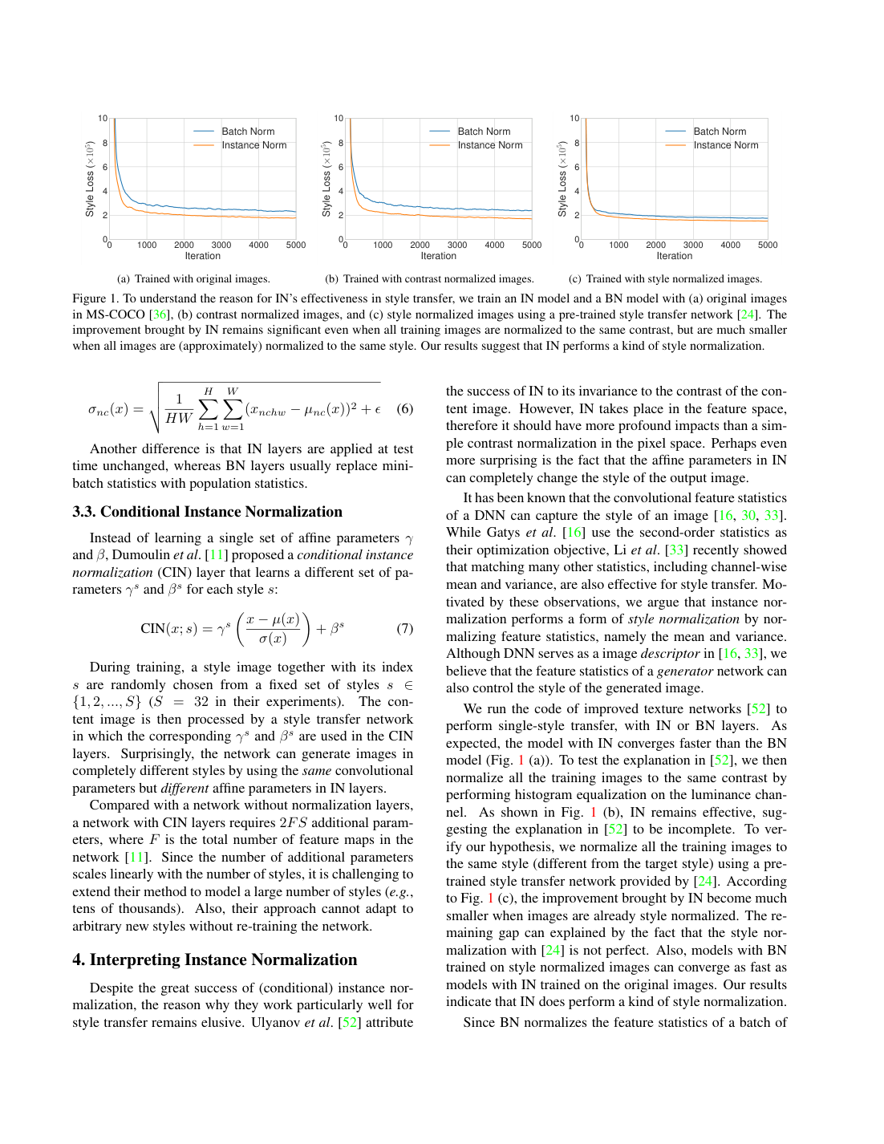
Figure: VGGNet configurations (A–E) showing increasing depth from 11 to 19 weight layers. VGG-16 (D) and VGG-19 (E) became the standard backbones for neural style transfer.

Key Architectural Choices
- All convolutional layers use only 3×3 filters (stride 1, padding 1)
- Five max-pooling layers with 2×2 window and stride 2
- Three fully connected layers at the end (4096 → 4096 → 1000)
- ReLU activation after every layer; no Local Response Normalization
- Configurations A through E tested, differing only in depth (11–19 layers)

Why 3×3 Filters Beat Larger Ones
Replacing a single 7×7 convolutional layer with three stacked 3×3 layers reduces parameters by 81% (27C² vs 49C²) while introducing more non-linearity and learning capacity. This is why VGGNet could go deeper without exploding model size.

Performance Results

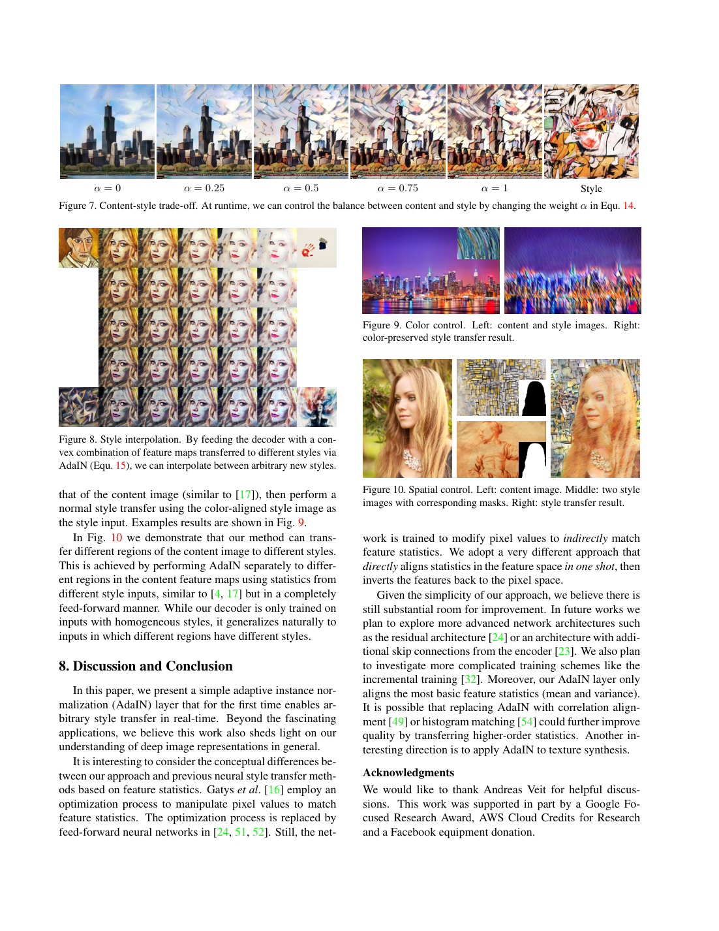
Figure: ILSVRC 2014 classification results. VGGNet significantly outperformed prior architectures and came close to the winner GoogLeNet with far fewer ensemble models.

Training Details
- Input: fixed-size 224×224 RGB images, mean RGB subtracted
- Mini-batch gradient descent, batch size 256, momentum 0.9
- Weight decay (L2 penalty 5×10⁻⁴), dropout ratio 0.5 on FC layers
- Initial learning rate 10⁻², reduced 3 times by factor of 10
- Trained for 370K iterations (~74 epochs)
- Multi-GPU training on 4× NVIDIA Titan Black GPUs; 2–3 weeks per model

Why VGGNet Became the NST Backbone
VGGNet's hierarchical feature representations are key: lower layers capture texture and color while higher layers capture semantic content (objects, scenes). This clean separation is precisely what neural style transfer exploits — using lower-layer feature correlations (Gram matrices) for style and higher-layer activations for content.

VGGNet's publicly released weights allowed researchers worldwide to immediately build on top of it for tasks like style transfer — without retraining from scratch. Its simplicity and depth made it the ideal "loss network."

PAPER 2 of 4 | The Original NST Breakthrough

A Neural Algorithm of Artistic Style
Gatys, Ecker & Bethge, University of Tübingen — arXiv 2015

The Breakthrough
This paper introduced the very concept of Neural Style Transfer. For the first time, a deep neural network was used to separate and recombine the content and style of arbitrary images, producing artistically styled photographs of remarkable quality.

Field | Value
Core Idea | Use VGG-19 features to independently represent content and style
Style Representation | Gram matrix of filter responses at multiple CNN layers
Content Representation | Raw activations at higher CNN layers (e.g., conv4_2)
Method | Iterative gradient-descent optimization (not feed-forward)
Speed | Minutes per image on a GPU (slow but pioneering)

How It Works
The method works by defining two loss functions: a content loss and a style loss. Starting from a white-noise image, the system iteratively updates pixel values to minimize a weighted combination of these losses.

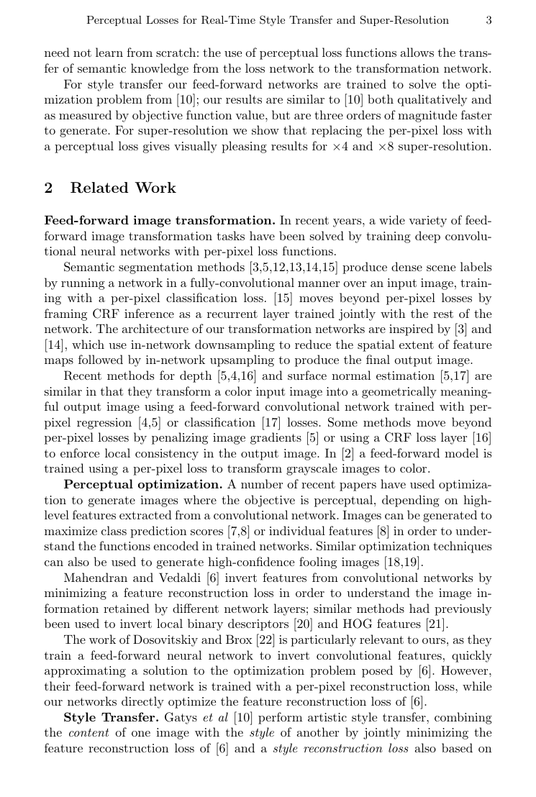
Figure 1: Content and Style Reconstructions. Higher CNN layers preserve content but lose exact pixels (content representations d, e). The Gram matrix style representations capture texture at increasing scales (style reconstructions a–e).

Content Representation
Content is represented by the raw feature activations at a specific high-level layer (conv4_2 of VGG-19). The content loss is the squared Euclidean distance between the feature maps of the generated image and the content target image.

Style Representation — The Gram Matrix
Style is captured using the Gram matrix — the inner product of vectorized feature maps within each CNN layer. This encodes the correlation between filter responses (which features tend to appear together), capturing texture, color palette, and local patterns without any spatial layout information.
- Style loss = sum of Frobenius-norm differences between Gram matrices across multiple layers
- Layers used: conv1_1, conv2_1, conv3_1, conv4_1, conv5_1 of VGG-19
- Content layer: conv4_2

Generating Stylized Images
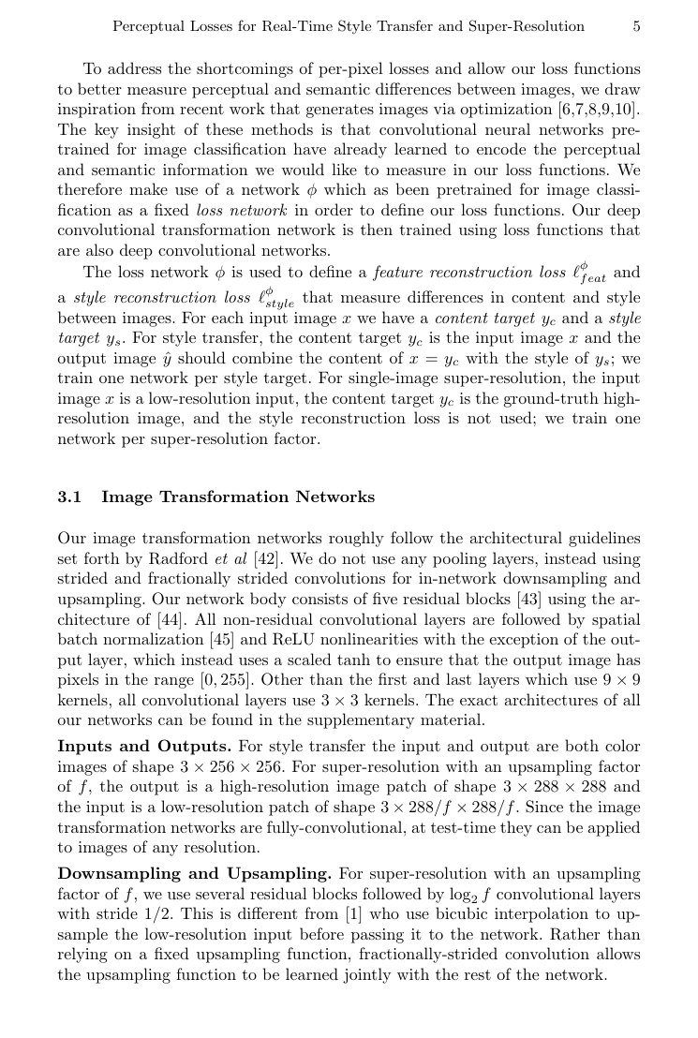
Figure 2: The same photograph (Neckarfront, Tübingen) rendered in the style of five different famous artworks: Turner (1805), Van Gogh (1889), Munch (1893), Picasso (1910), and Kandinsky (1913).

Content-Style Trade-off
The ratio α/β controls how much the output resembles the content photo versus the style painting. A small α/β (e.g., 10⁻⁴) creates heavily stylized images; a large ratio preserves more photographic content. This trade-off can be tuned continuously.

Limitations of This Approach
- SLOW: Each image requires 500+ iterations of backpropagation through VGG-19 — typically 1–10 minutes per image
- One style at a time: a separate optimization run is needed for each new style–content pair
- No real-time capability: impractical for video or interactive applications

The key insight of Gatys et al. — that CNNs trained on object recognition learn to separate content from style — launched the entire field of neural style transfer and inspired a generation of follow-up research.

PAPER 3 of 4 | Making NST Real-Time (Fixed Styles)

Perceptual Losses for Real-Time Style Transfer and Super-Resolution
Johnson, Alahi & Fei-Fei, Stanford University — ECCV 2016

The Problem It Solved
Gatys et al.'s optimization approach was elegant but far too slow for practical use. Johnson et al. asked: can we train a feed-forward neural network to learn to apply a specific artistic style, so that at inference time stylization takes milliseconds instead of minutes?

Field | Value
Core Idea | Train a feed-forward image transformation network using perceptual losses
Speed Gain | ~1000× faster than Gatys et al. (real-time at 20 FPS for 512×512)
Loss Network | Pre-trained VGG-16 (fixed — not updated during training)
Training Data | 80,000 images from MS-COCO dataset
Tasks Demonstrated | Artistic style transfer + single-image super-resolution

System Architecture
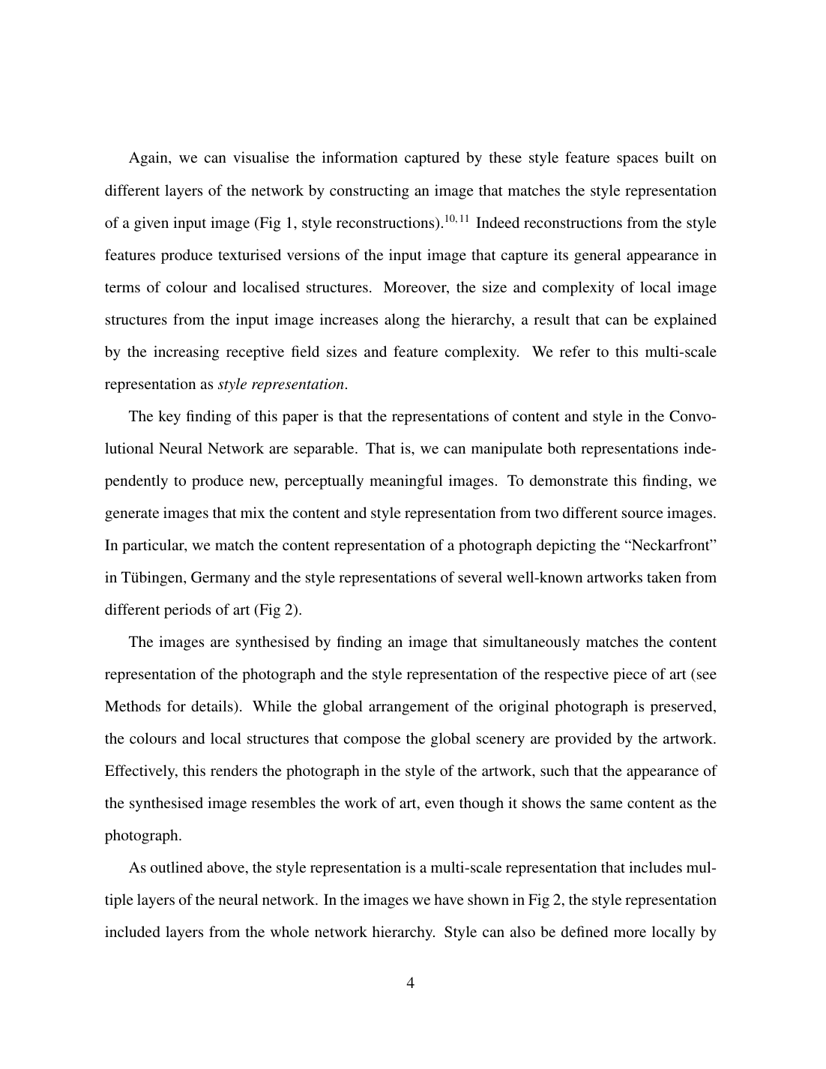
Figure 2: System overview. The image transformation network (left) learns to produce stylized outputs. The VGG-16 loss network (right) stays fixed and measures perceptual quality. The transformation network is trained but the loss network is not.

Two Key Components
1. Image Transformation Network
A deep residual convolutional network that takes an input image and produces an output image in a single forward pass. It uses strided convolutions for downsampling, residual blocks for processing, and fractionally-strided convolutions for upsampling. No pooling layers are used.

2. Perceptual Loss Functions
Instead of per-pixel loss (which ignores perceptual quality), the method uses the pre-trained VGG-16 network to compute:
- Feature Reconstruction Loss: Minimizes the Euclidean distance between VGG feature maps of the output and content target images (measured at relu2_2)
- Style Reconstruction Loss: Minimizes the difference between Gram matrices of the output and style target images (measured at relu1_2, relu2_2, relu3_3, relu4_3)

Style Transfer Results
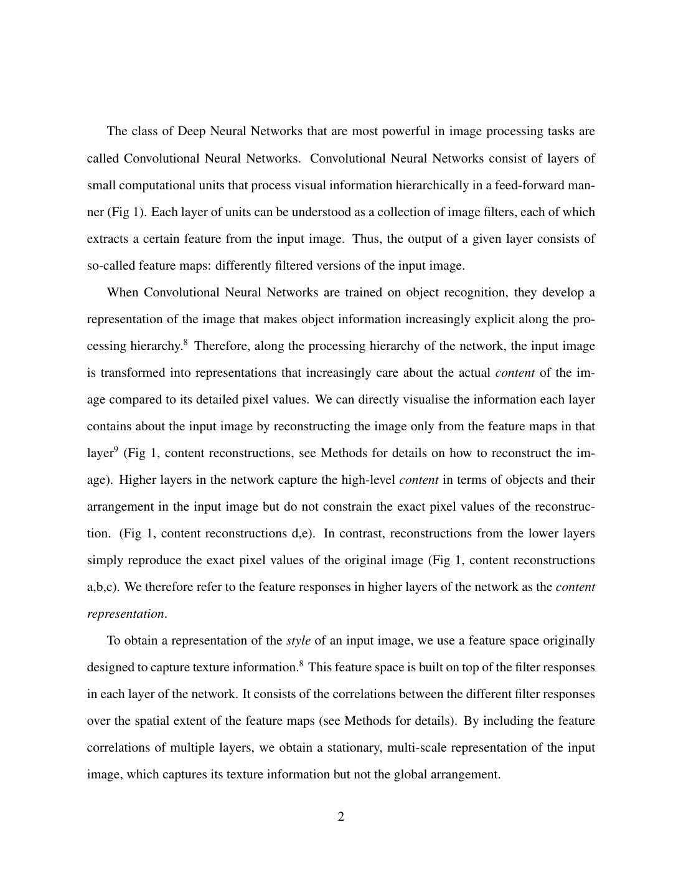
Figure 1: Example style transfer (top row) and ×4 super-resolution (bottom row). The method achieves quality comparable to Gatys et al. but is three orders of magnitude faster.

Speed Comparison
Image Size | Gatys (500 iter.) | Johnson (Ours) | Speedup
256 × 256 | 15.86s | 0.015s | ~1060×
512 × 512 | 54.85s | 0.05s | ~1026×
1024 × 1024 | 214.44s | 0.21s | ~1042×

Super-Resolution Application
The same framework was applied to super-resolution (×4, ×8). Training with a perceptual (feature) loss rather than a per-pixel loss produces visually sharper fine details — such as individual eyelashes or hat elements — even though PSNR scores are lower. This demonstrates that perceptual quality and pixel-level metrics can diverge significantly.

Remaining Limitation
- One network per style: Each transformation network is trained for one specific style target
- Generalizing to new styles requires retraining a new network from scratch
- Supporting N styles means training N separate networks — not scalable

Johnson et al. proved that the quality gap between optimization-based and feed-forward NST could be closed while gaining three orders of magnitude in speed — enabling real-time style transfer for the first time.

PAPER 4 of 4 | Arbitrary Styles in Real-Time (The Breakthrough)

Arbitrary Style Transfer in Real-Time with Adaptive Instance Normalization
Huang & Belongie, Cornell University — ICCV 2017

The Problem It Solved
Johnson et al. achieved real-time speed but each model was locked to one style. To apply a different artistic style, you needed a completely different network. Huang & Belongie asked: can we build a single network that handles any style at inference time, without retraining?

Field | Value
Core Innovation | Adaptive Instance Normalization (AdaIN) layer
Key Insight | Instance Normalization performs implicit style normalization
Style Flexibility | Unlimited — any unseen style works at test time
Speed | 56 FPS (256px), 15 FPS (512px) on GPU — comparable to single-style methods
Backbone | VGG-19 encoder (fixed) + learned decoder
Training Data | MS-COCO (content) + WikiArt paintings (style)

The Key Insight: Instance Normalization = Style Normalization
The authors discovered why Instance Normalization (IN) works so well for style transfer: IN normalizes the mean and variance of feature maps per-channel per-image, effectively normalizing the style of each image. This was verified experimentally by training models on images that were pre-normalized to the same style — when styles were already normalized, IN lost most of its advantage.

The AdaIN Layer
Adaptive Instance Normalization extends Instance Normalization by adaptively computing the normalization parameters from a style image rather than using learned fixed parameters:
AdaIN(x, y) = σ(y) · ((x − μ(x)) / σ(x)) + μ(y)
Where x is the content feature map and y is the style feature map. AdaIN aligns the channel-wise mean and variance of the content features to match those of the style features — effectively transferring style statistics in one single feed-forward operation.

Network Architecture
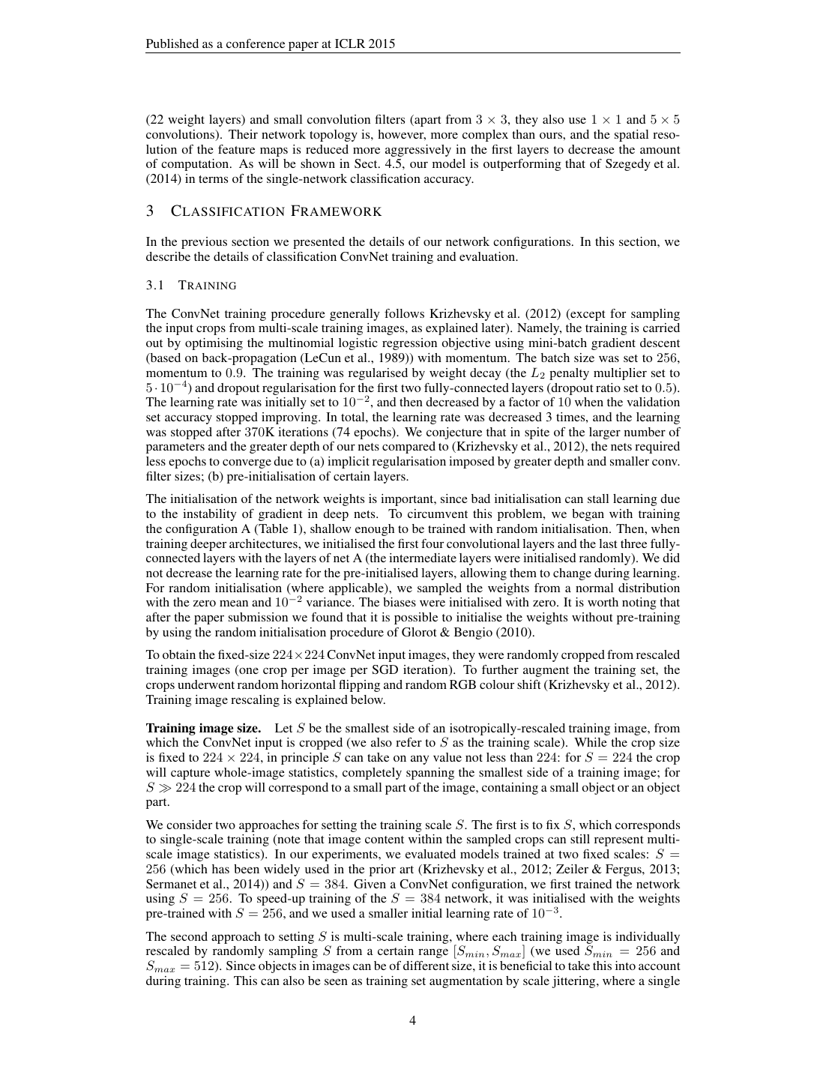
Figure 2: AdaIN architecture overview. The VGG-19 encoder (fixed) encodes both content and style images. The AdaIN layer aligns statistics. A learned decoder inverts the result back to an image.

Three-Stage Pipeline
- Stage 1 — Encode: Both content image c and style image s are passed through a fixed VGG-19 encoder to obtain feature maps f(c) and f(s)
- Stage 2 — AdaIN: The layer computes t = AdaIN(f(c), f(s)) by transferring the mean and variance of style features to the content features
- Stage 3 — Decode: A learned decoder g maps t back to the image space, producing the final stylized image T(c, s) = g(t)

Style Transfer Results
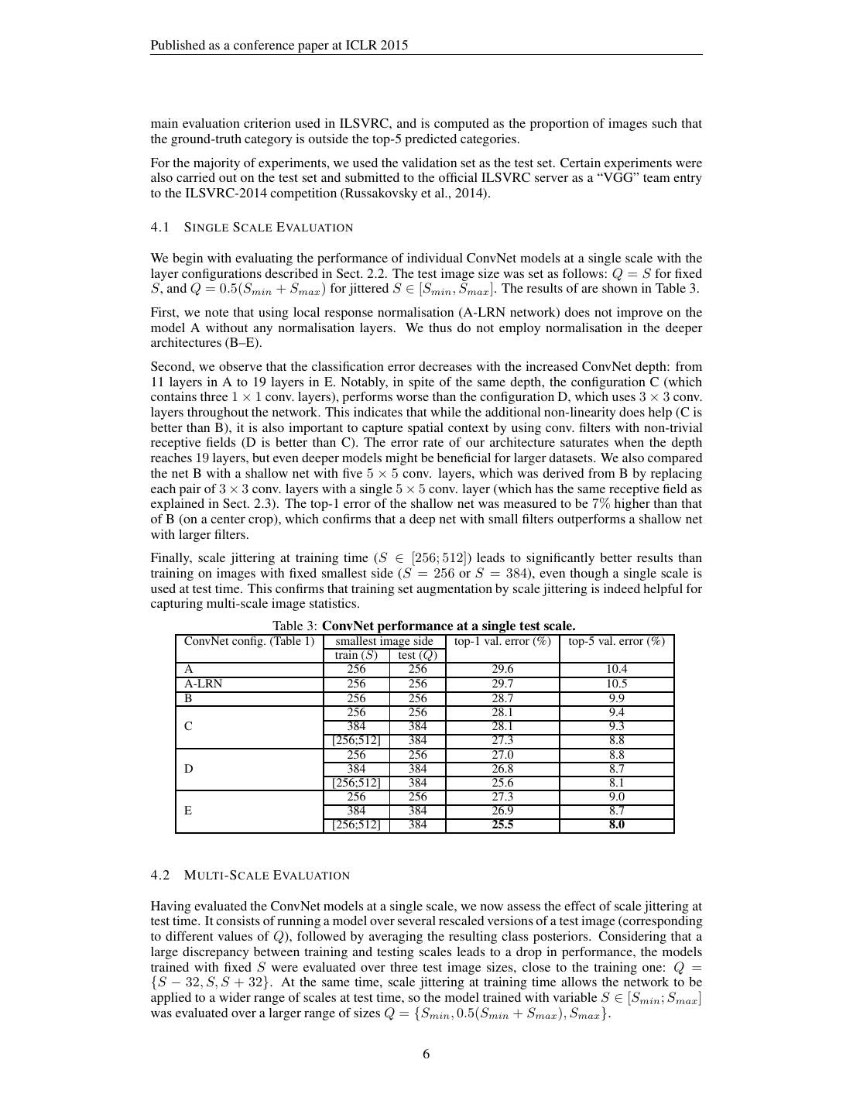
Figure 4: Style transfer comparison across four methods. AdaIN (Ours) generalizes to unseen test styles while achieving quality competitive with optimization-based Gatys et al. and single-style Ulyanov et al.

Runtime User Controls (Unique to This Method)
1. Content-Style Trade-off
At test time, the degree of stylization can be smoothly adjusted by interpolating between the content features and the AdaIN output: T(c, s, α) = g((1−α)·f(c) + α·AdaIN(f(c), f(s))). No retraining required.
2. Style Interpolation
Multiple styles can be blended by combining AdaIN outputs with different weights: T(c, s₁,...,sK, w₁,...,wK) = g(Σ wk · AdaIN(f(c), f(sk))). This enables smooth artistic blending.
3. Color and Spatial Control
Users can preserve the original color palette of the content image, or apply different artistic styles to different spatial regions of the same image — all in a fully feed-forward manner.

Speed Comparison vs. All Prior Methods
Method | 256px (sec) | 512px (sec) | # Styles Supported
Gatys et al. | 14.17 | 46.75 | Unlimited (slow)
Chen & Schmidt | 0.171 | 3.214 | Unlimited (medium)
Ulyanov et al. | 0.011 | 0.038 | 1 (fixed)
Dumoulin et al. | 0.011 | 0.038 | 32 (fixed set)
AdaIN (Ours) | 0.018 | 0.065 | Unlimited (real-time)

AdaIN resolved the fundamental speed-flexibility dilemma in neural style transfer: for the first time, arbitrary new styles could be applied in real-time using a single trained network, without any retraining or modification at inference time.

Conclusion: The Evolution at a Glance

The four papers trace a clear and elegant progression: from building the right backbone, to proving the concept, to making it fast, to making it universal.

Paper | Method | What It Added | Speed | Styles
VGGNet (2014) | Deep CNN Classifier | Feature backbone for NST | N/A | N/A
Gatys et al. (2015) | Optimization (Gram Matrix) | Proof of concept for NST | Minutes | Any (but slow)
Johnson et al. (2016) | Feed-Forward Network | Real-time NST | Milliseconds | 1 per network
Huang & Belongie (2017) | AdaIN + Decoder | Arbitrary + real-time NST | Milliseconds | Unlimited

Key Takeaways
- Every NST paper uses VGGNet's pre-trained features — it is the universal backbone of the field
- The Gram matrix is the mathematical heart of style representation — correlations between features = texture and style
- Perceptual (feature-based) losses are dramatically better than per-pixel losses for image generation tasks
- Instance Normalization implicitly normalizes style — AdaIN turns this into an explicit, controllable mechanism
- The field moved from proof-of-concept (2015) to real-time arbitrary stylization (2017) in just two years

Prepared as a study guide to Neural Style Transfer Research • Papers: 2014–2017

